**FPP pelagic piscivores originaly includes:** Yellowfin tuna, skipjack tuna, Bigeye tuna,

But also: The pelagic piscivores Apogonops anomalus, Trachurus declivis, Brama brama Lepidopus caudatus and (Macruronus novaezelandiae in demersal shallow omnivore) from Blaber et al 1987)

Primarily consume the shelf-break myctophid *Lampanyctodes hectoris*; their diet is narrow, with a large overlap between species.

***Apogonops anomalus*** and Lepidopus caudatus take significant quantities of euphausiids.

**Trachurus declivis** (jack mackerel) fed mainly on Lampanyctodes hectoris (lanternfish), except in October when pelagic Gastropoda and fish larvae formed the bulk of the prey.

***Brama brama*** apparently opportunistic feeder on small fishes, cephalopods, amphipods, and euphausiids.

**Yellowfin tuna**

Fig. 5 Relative proportions of prey families contributing[1% wet weight to prey biomass for fish predators off eastern Australia. ALX Lancetfish, DOL Dolphinfish, SMA Mako shark, YFT Yellowfin tuna, MLS Striped marlin, SBF Southern bluefin tuna, BET Bigeye tuna,

BSH Blue shark, ALB Albacore, SWO Swordfish

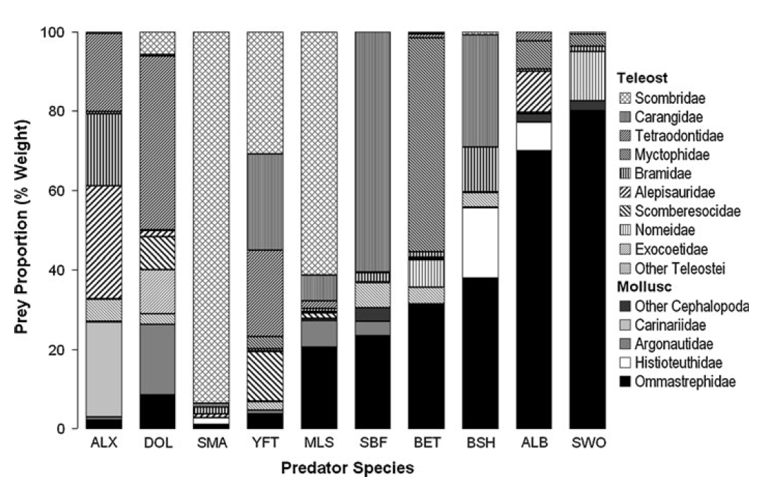

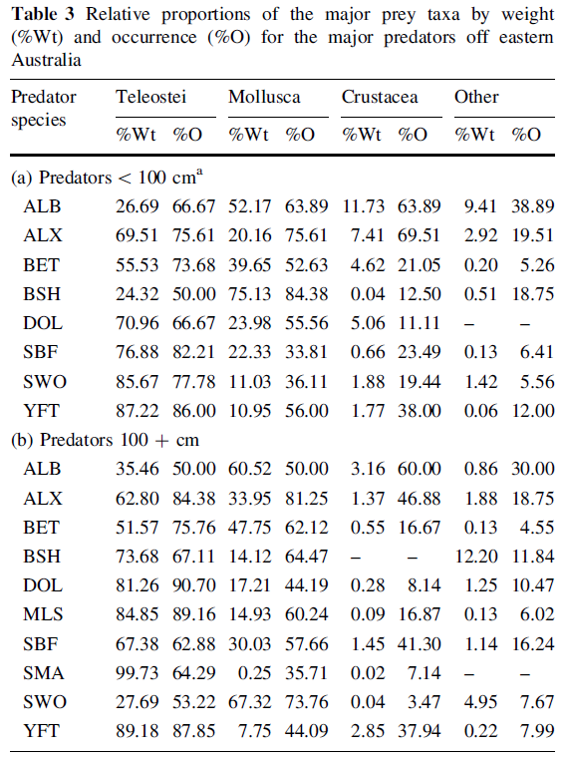

Albacore juveniles 50–75 cm LCF diet is a mixture of crustacea, squid, and small fish

|  |  |
| --- | --- |
| **prey item** | **probability of consuming** |
| ZME zooplankton | 0.3 |
| CEP Cephalopod | 0.3 |
| FMP mesopelagic fish | 0.05 |

Albacore 76–95 cm LCF feed primarily on small fish and squid

|  |  |
| --- | --- |
| **prey item** | **probability of consuming** |
| ZME zooplankton | 0.3 |
| CEP Cephalopod | 0.3 |
| FMP mesopelagic fish | 0.1 |

Albacore >100 cm LCF predators>100 cm, albacore and swordfish were the only two predators with a mainly squid diet.

|  |  |
| --- | --- |
| **prey item** | **probability of consuming** |
| ZME zooplankton | 0.05 |
| CEP Cephalopod | 0.3 |
| FPK pelagic planktivores | 0.05 |
| FMP mesopelagic fish | 0.2 |

Marlin:

|  |  |
| --- | --- |
| **prey item** | **probability of consuming** |
| FPK pelagic planktivores | 0.2 |
| CEP Cephalopod | 0.1 |
| SAR sardines | 0.1 |
| FPP pelagic piscivores | 0.3 |

Apogonops anomalus, Trachurus declivis, Brama brama:

|  |  |
| --- | --- |
| **prey item** | **probability of consuming** |
| ZKL krill | 0.2 |
| CEP cephalopod | 0.2 |
| ZME zooplankton | 0.1 |
| FPK Pelagic planktovores | 0.2 |
| FMP mesopelagic fish | 0.3 |
| FPI small | 0.1 |
| FPP small | 0.1 |
| FSP small | 0.1 |

Blaber SJM, Bulman CM (1987) Diets of fishes of the upper continental slope of eastern Tasmania: content, calorific values, dietary overlap and trophic relationships. Mar Biol 95: 345–356.

Jock W. Young, Matt J. Lansdell, Robert A. Campbell, Scott P. Cooper. Francis Juanes, Michaela A. Guest 2010. Feeding ecology and niche segregation in oceanic top predators

off eastern Australia. Marine Biology 157, 2347-2368

<http://species-identification.org/species.php?species_group=fnam&id=1765>